**Flashing Tutorial**

*Thank you for having XD for your daily life.*

*Hope you have a good memory with XD.*

We will use XD68 flashing process as our course,if you use other pcbs, pls refer other pcb default layout link

First of all, let us test the PCB is on its good form.

The default layout is the following image. (*link* http://www.keyboard-layout-editor.com/#/gists/3405611a7e791b0b69fa27336ca791ef)

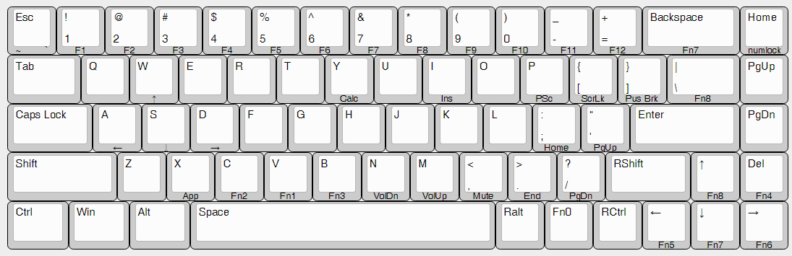

Do try not to solder any switches before you finished test. It would make you lost lots of money and time. For sure, we already double checked the PCB’s condition before it goes to you.

Let us see what kind of layouts XD68 supports. (see the following image)

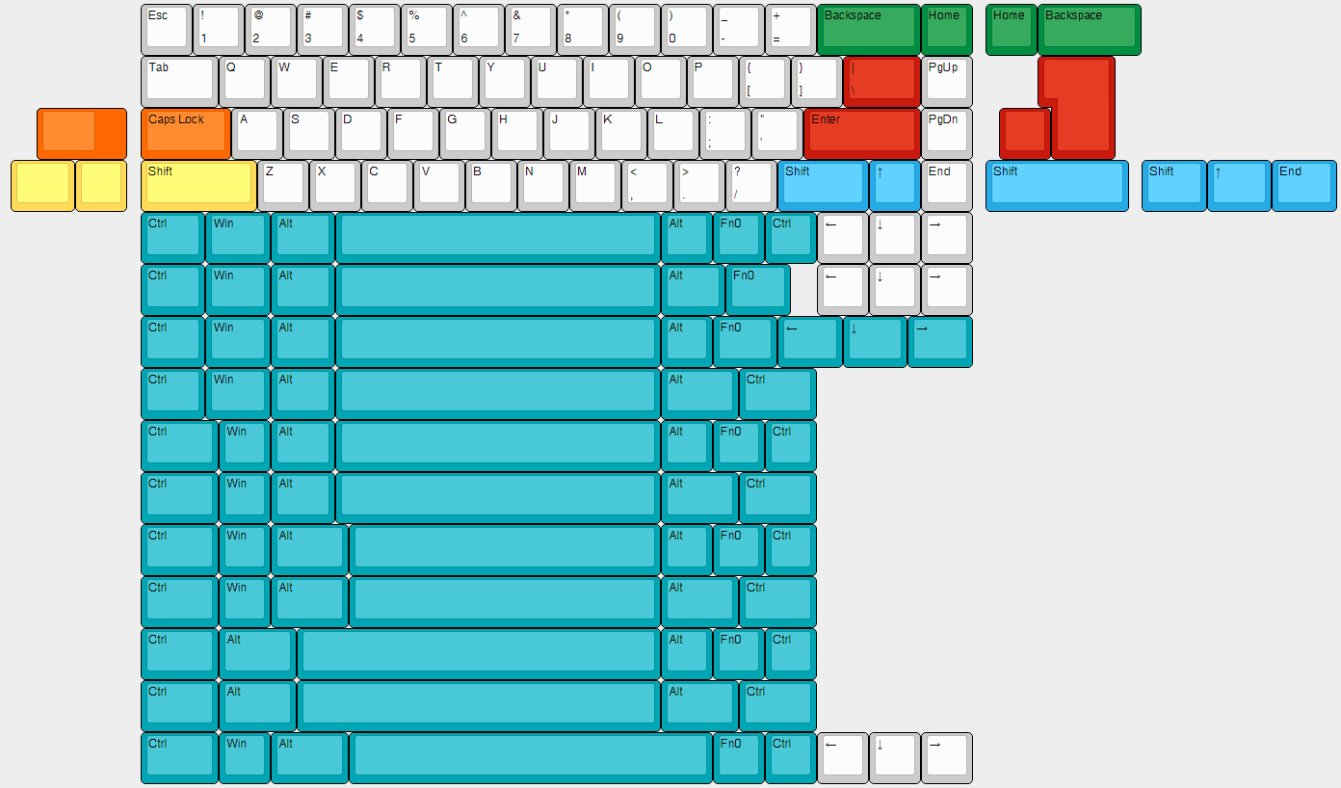

**HOW TO REFLASH**

**Step 1**

Open keyboard-layout-editor.com and edit the layout you like according to the layouts that XD68 supports. If you are new to the mechanical keyboard world, highly recommend using the default lay out page to adjust the layout. (see image below)

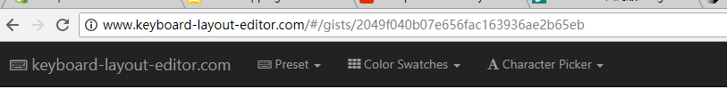

For example, we change ENTER key to ISO ENTER key. According to the ISO layout, to select the ‘I\’ and change the width to 1u.

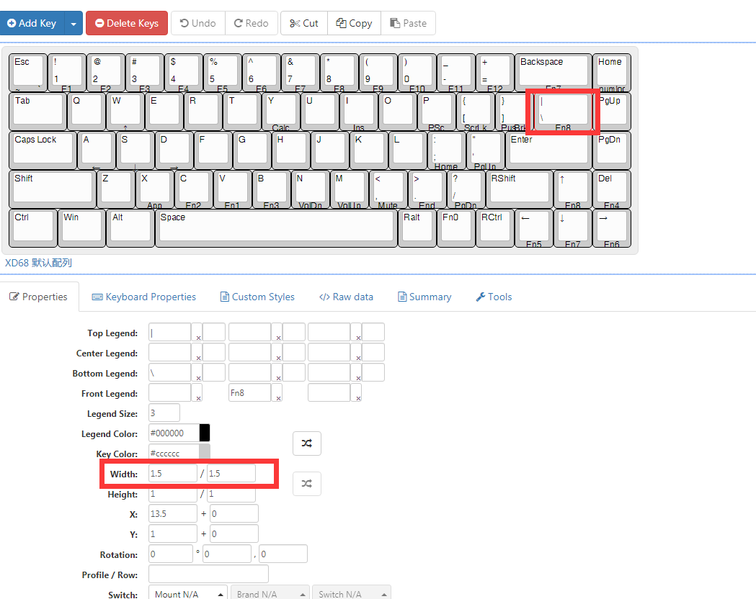

Step 2

To click Add key and choose add ISO Enter key

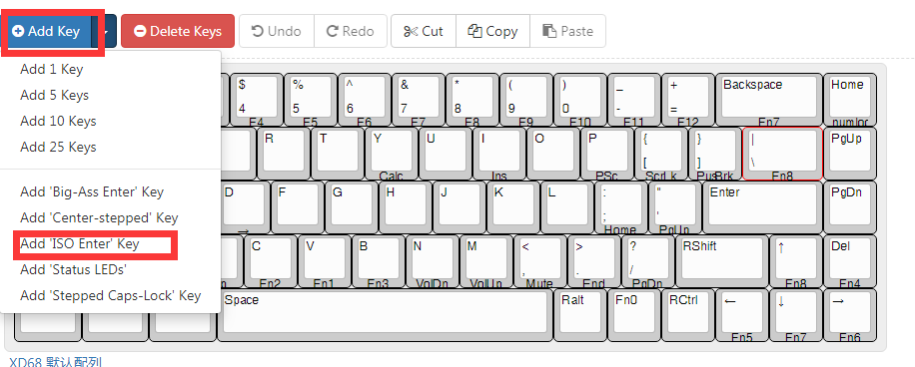

Use arrow keys to move the ISO Enter key we added to the proper position.

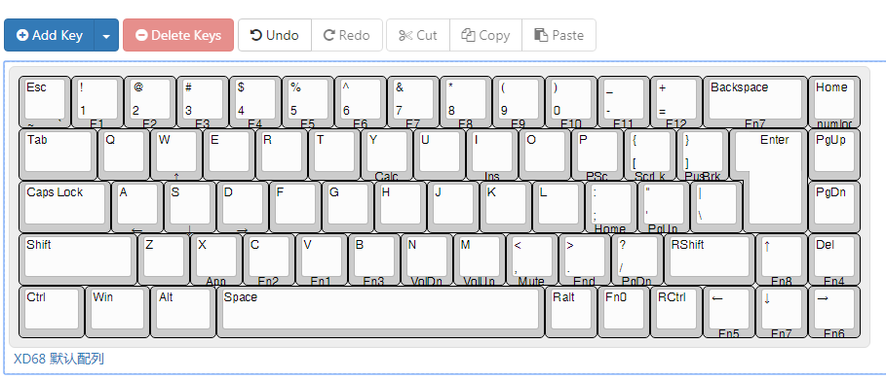

Step 3

Go to <https://xd.tkg.io/> ，and make sure that you have clicked Advanced Mode

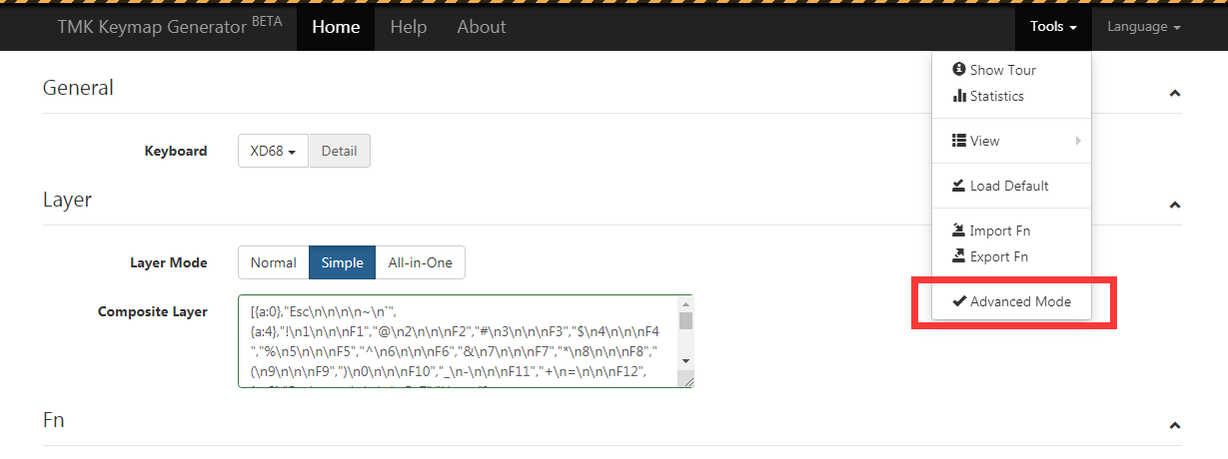

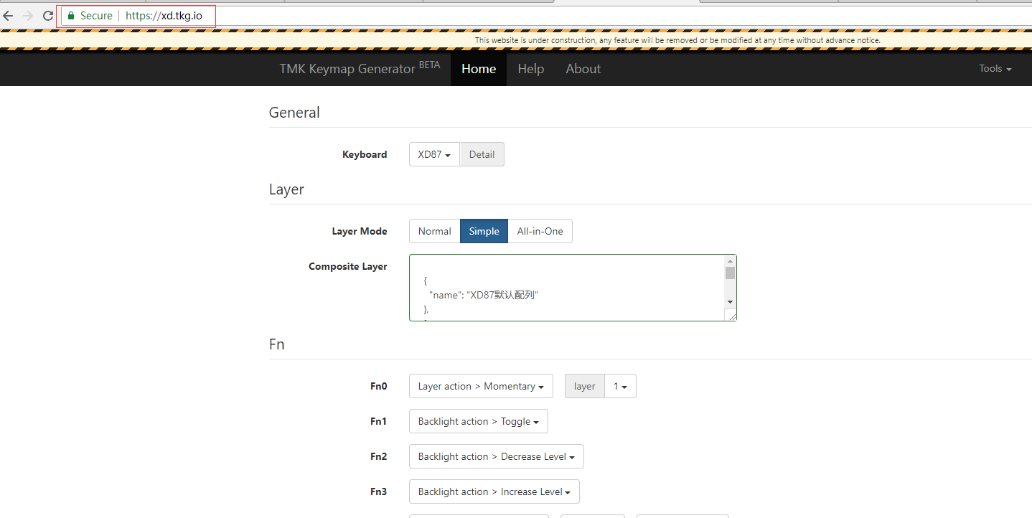

Then select XD68 from Keyboard drop menu

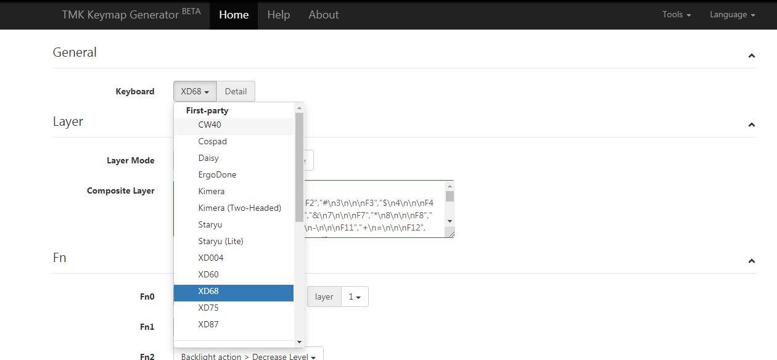

Copy the Rowdata that we just created in keyboar-layout-editor.com. And paste into the simple window.

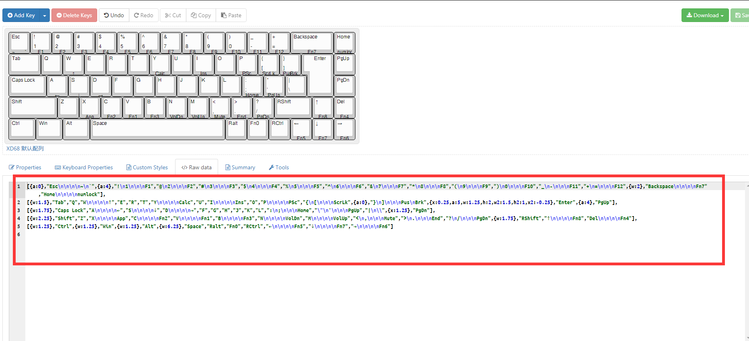

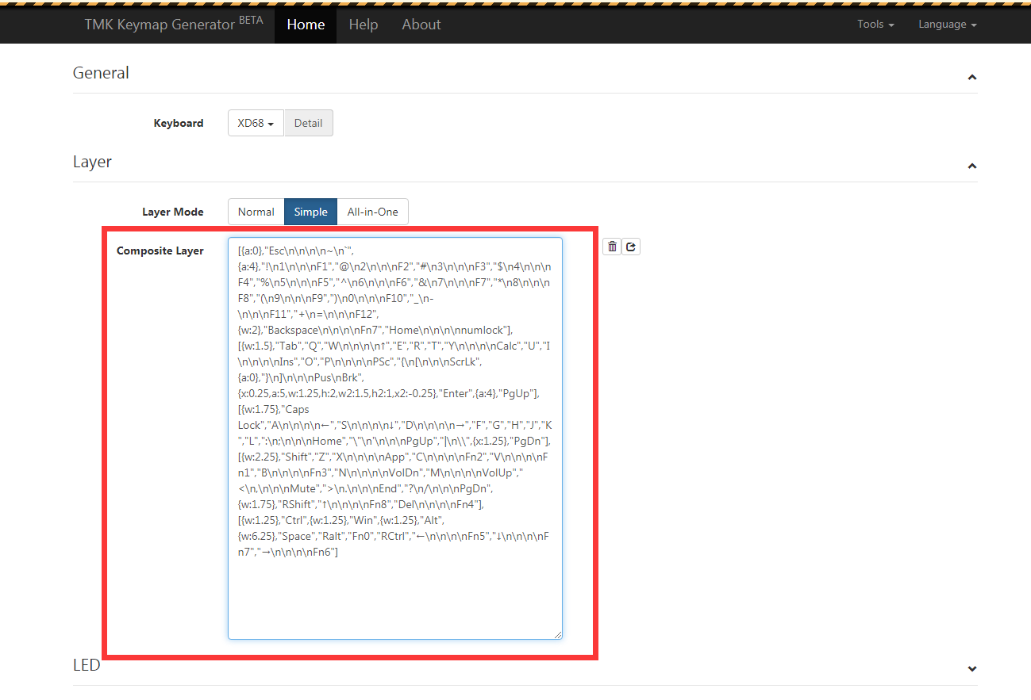

Step 4

Adjust FN and LED settings

FN setting

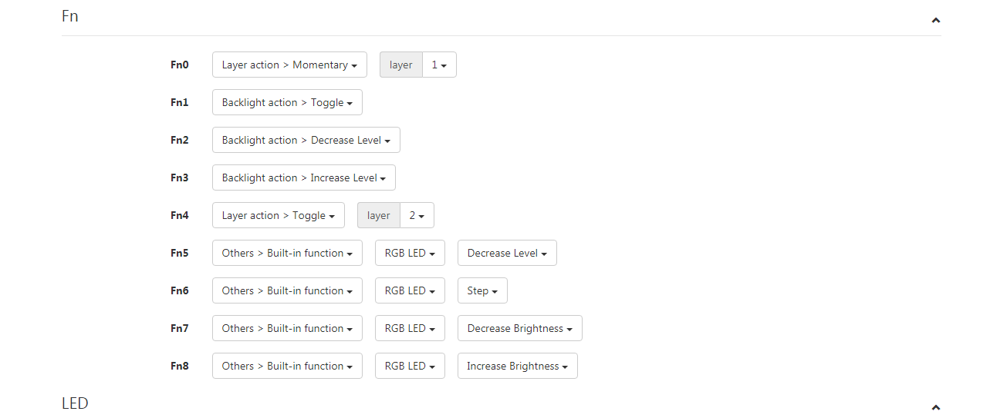

LED Setting

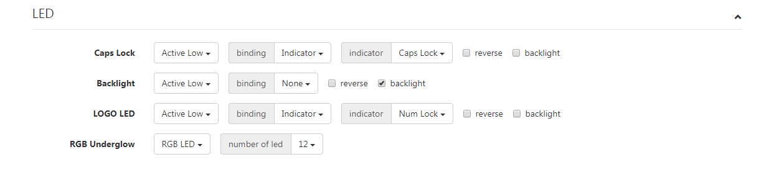

Step 5

Burn the eep file

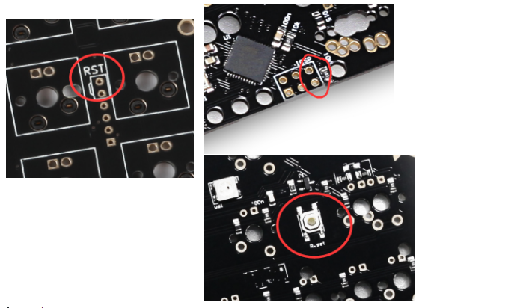

To press the reset button or touch holes(shown at red circle) with tweezer. After then, the burn button changes to green.

(Attention: if the burn button doesn’t change to green or show the ‘no device found’, it means you don’t have **Zadig for Atmel DFU.exe installed**. Please kindly install the driver, then try again.

If it shows App not founded, pls Click for more information, then it will help you install tmk extension )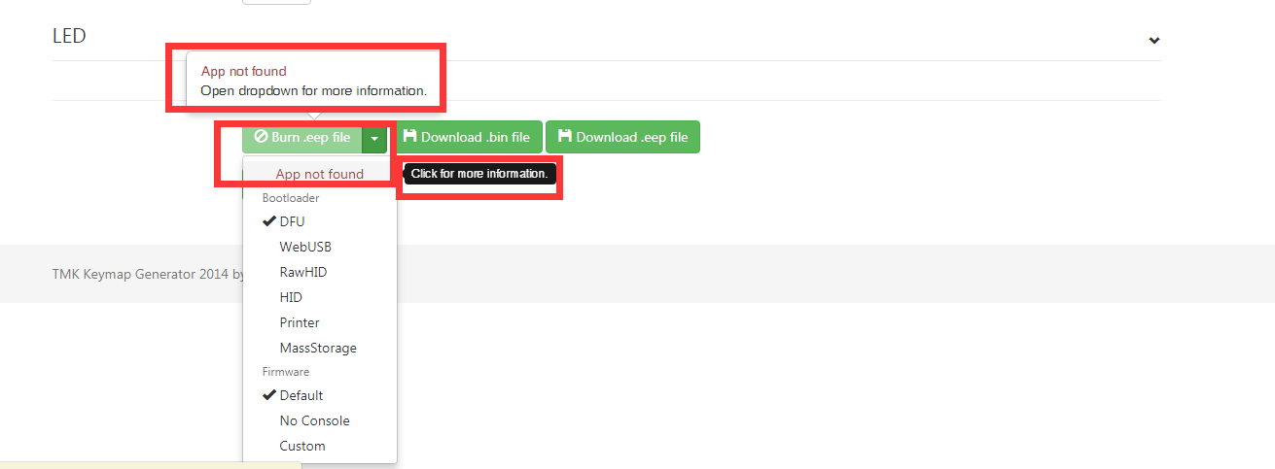

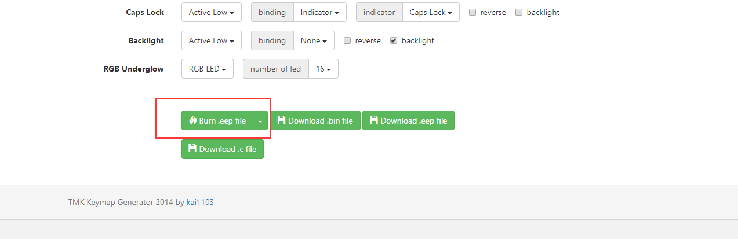

Click Burn button and wait the process finished.

Now, we have a XD68 with ISO Enter key.

**NOTE:**

* Zadig for Atmel DFU.exe is required for installing when you reflash the XD series PCB at first time.